**Di Khalyastre (1922-1924)**

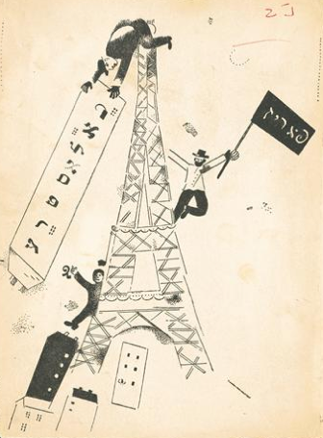

*Khalyastre*, vol. 2, (1924). Cover design by Marc Chagall. The flags read (in Yiddish) “Khalyastre” (left) and “Paris” (right).

Di Khalyastre (also Di Khaliastra, “The Gang” in Yiddish) was a major Yiddish avant-garde movement and literary magazine active in Warsaw between 1922 and 1924. Influenced by German Expressionism and Russian Cubo-Futurism, it took part in an international network of artistic and intellectual exchanges that connected it with Kiev, Moscow, Berlin, and Paris. The group was formed in Warsaw and published the first issue of its namesake literary magazine in 1922; the second and last issue was published in Paris in 1924. Distancing itself from both naturalism and neo-Romantic idealizations of Jewish traditions, Khalyastre was characterized by its praise of chaotic forms and explosive imagery, its angst-ridden, often nightmarish themes, and its innovative use of graphic design. Marc CHAGALL created most of the illustrations, including the cover design of the second issue. An association of like-minded writers and visual artists rather than a unified artistic movement, Khalyastre was founded by Yiddish poets Peretz MARKISH, Uri Zvi Greenberg (also Tsevi Grinberg), and Melech Ravitch. Prose writers Oyzer Varshavski and Israel Joshua Singer, and poet H. LEYVIK were also associated with the group. Divergent political choices led to its dissolution in 1924.

[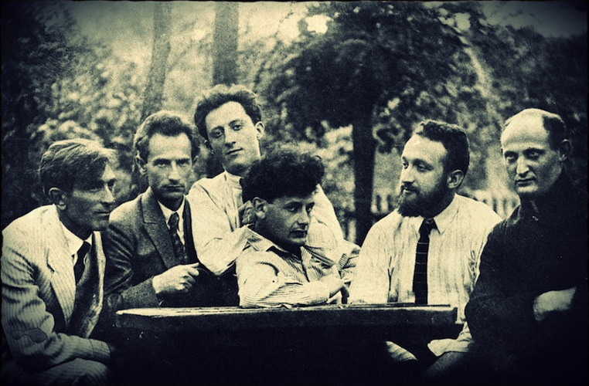](http://www.google.com/url?sa=i&rct=j&q=&esrc=s&source=images&cd=&docid=KkRPterX-j90GM&tbnid=94faUy0wEh8T-M:&ved=0CAUQjRw&url=http://www.yiddishkayt.org/hirshbein/&ei=Jvs-U-elDqe0sQSmkoD4AQ&bvm=bv.64125504,d.b2I&psig=AFQjCNH1_d7mVdPtAhhRwA6kGgmDMvp0ZA&ust=1396722839341862)

First members of Khalyastre in a park, Warsaw, 1922: (from right to left) Israel Joshua Singer, Melech Ravitch, Peretz Markish, Uri Zvi Greenberg, and friends Peretz Hirschbein and Mendl Elkin.

**Timeline:**

1915: Death of I.L. Peretz, the leading figure of Yiddish letters in Warsaw.

November 1918: End of the First World War.

1919: Moyshe Broderzon creates the *Yung-Yidish* (Young Yiddish) group in Łódź (near Warsaw), a precursor to *Khalyastre*. Uri Zvi Greenberg and Melech Ravitch are associated with the group.

February 1919 - March 1921: Polish-Soviet war.

1921: Melech Ravitch, Uri Zvi Greenberg, and Peretz Markish all move to Warsaw.

1921: Uri Tsevi Grinberg publishes *Mefisto* (Mephisto), a modern rewriting of Goethe’s *Faust*; Peretz Markish publishes *Di Kupe* (The Heap).

January 28th, 1922: Poetry reading organized in Warsaw by the literary magazine *Ringen*, with Melech Ravitch, Uri Zvi Grinberg, and Peretz Markish. Taking place on a Saturday, it is conceived as an alternative secular Sabbath celebration. The reading is well attended, but perceived by the observant Jewish community as a provocation. This controversial event consecrates the prominence of the Khalyastre group in the Warsaw Yiddish avant-garde.

1922: First issue of *Khalyastre*.

1922-1923: Uri Zvi Greenberg publishes his own literary magazine, *Albatros* (three issues); Peretz Markish visits Paris, London, and Palestine.

1923: Peretz Markish publishes *Radio*, a major work of Modernist poetry; Uri Zvi Greenberg moves to Palestine and starts writing exclusively in Hebrew.

1924: Oser Varshavski settles in Paris; Peretz Markish visits Paris and Berlin. Second and last issue of *Khalyastre*, published in Paris, written by Peretz Markish and Oyzer Varshavski, entirely illustrated by Marc Chagall.

1926: Peretz Markish settles permanently in the Soviet Union.

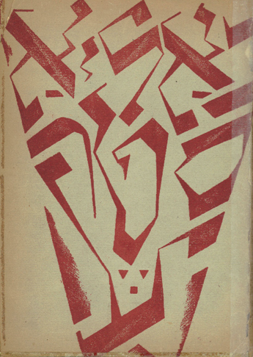

First issue of Khalyastre (Warsaw 1922): Cover design by V. Weintraub.

Though short-lived (1922-1924), the Khalystre movement, based in Warsaw, is of crucial importance in the history of modern Yiddish literature. Its goal was to overcome the marginal status of literary creation in Yiddish, and to make it an integral part of international modernism in constant dialogue with the Russian, French, and German avant-gardes. This aspiration was symbolized by Marc Chagall’s cover for the second issue, in which the group’s flag is planted on the Eiffel Tower, a beacon of international modernism celebrated by APOLLINAIRE and Robert DELAUNAY. International in scope, the movement nevertheless opposed cultural assimilation, advocating for a new secular Yiddish culture that would help preserve a distinct Jewish identity in Eastern Europe.

Most members of Khalyastre were not originally from Warsaw: Melech Ravitch and Uri Zvi Greenberg both came from Galicia (then part of the Austro-Hungarian Empire, now divided between Poland and Ukraine), and Peretz MARKISH from Kiev. They came to Warsaw in 1921, shortly after the end of the Soviet-Polish war, because the city seemed to offer a favorable terrain for their political and literary program: Warsaw was home to a thriving Yiddish cultural life supported by a large Yiddish-speaking readership. The city’s cultural landscape was dominated by two major artistic styles: naturalism and neo-romanticism, the latter marked by the legacy of I.L. PERETZ (1852-1915), a towering figure of Yiddish letters.

As an avant-garde movement breaking with these mainstream artistic styles, Khalyastre positioned itself as a disruptive force in the city’s Yiddish cultural landscape. They promoted radical experimentation, shock aesthetics, and provocative self-advertisement. Narrative prose was the privileged medium of naturalism and neo-romanticism; the Khalyastre movement was instrumental in shifting the center of gravity of Yiddish letters to lyrical poetry. Although the journal featured short stories by major prose writers like Israel Joshua Singer or Oyzer Varshavski, most of its members were poets, including Markish, Ravitch, and Greenberg. This genre corresponded to the group’s emphasis on the untrammeled expression of inner life in the face of a dystopian, apocalyptic present. Their poetry is characterized by free verse (generally without rhymes) often corresponding to the sentence structure. Overall, the Khalyastre poets sought for expressivity and directness instead of hermeticism.

The Khalyastre movement was often labeled Yiddish expressionism (Wolitz 1981), and was directly influenced by German Expressionism, especially literary reviews from the early 1910s such as *Der Sturm* (The Storm) and *Die Aktion* (The Action). But unlike German Expressionism’s vitalist utopianism and its longing for a brutal but ultimately beneficial change, the Khalyastre movement promoted social and cultural renewal as a survival strategy in the face of catastrophe. Images of physical pain, death, and blood (exemplified by the Khalyastre poets’ appropriation of the motive of Christ on the cross) dominate their works, expressing the angst and utter pessimism of the lyrical I. Prewar German Expressionists had no direct experience of mass destruction, whereas for the Khalyastre poets images of apocalyptic violence were all too recent memory, calling to mind the First World War and the Polish-Soviet War, but also the Ukrainian pogroms of 1919-1920 that resulted in between 30,000 and 70,000 Jewish victims. Peretz Markish evokes these pogroms in his poem *Di Kupe* (The Heap) (1921), in which the poet gives voice to a heap of unburied corpses in a series of nightmarish images. Thus, Khalyastre paradoxically combined the forward-looking dynamic of the Modernist avant-gardes with a sense of angst and pessimism, as expressed bythe epigraph to the first issue of *Khalyastre*, a poem by Moyshe Broderzon:

Mir yungen, mir a freylekhe tsezungene khalyastre

Mir geyen in an umbavustn veg,

In tife moreshkhoyredike teg

In nekht fun shrek

*Per aspera ad astra!*

We, the young, a happy, boisterous gang

We’re trodding on an unknown path

Through deeply melancholic days

Through nights of fright

*Per aspera ad astra!*

(Translation by Seth Wolitz)

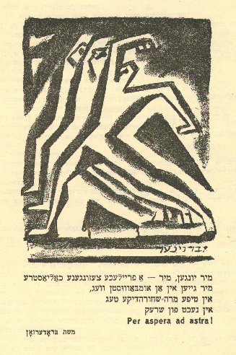

Frontispiece of the first issue of *Khalyastre*: Poem by Moyshe Broderzon, illustration by I. Brauner (Warsaw 1922).

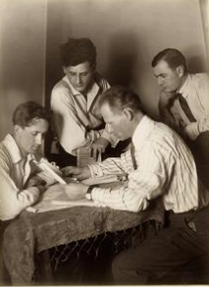

Members of Khalyastre in Paris around 1924: (from left to right) Oyzer Varshavski, Peretz Markish, H. Leyvik, and an unidentified man. Photograph by J. Deutscher.

**References and further reading**

Ertel, Rachel (ed.) (1989) *Khaliastra, la bande: Revue littéraire Varsovie 1922 – Paris 1924.* Paris: Lachenal & Ritter. A complete French translation of the two issues of the *Khalyastre* magazine. Includes facsimiles of the original illustrations, and a major essay by Rachel Ertel: “Khaliastra et la modernité européenne” (Khalyastre and European Modernity).

Greenwald, Roy (2010) ‘Pogrom and Avant-Garde: Peretz Markish's *Di kupe*’, *Jewish Social Studies*, Vol. 16, No. 3. Bloomington, IN: University of Indiana Press. An in-depth study of Peretz Markish’s *Di Kupe* (The Heap) and its relationship with avant-garde aesthetics.

Rozier, Gilles (2011) *D’un pays sans amour: roman.* Paris: Grasset. A very personal and well-documented account of the author’s discovery of the life and works of Khalyastre members Peretz Markish, Uri Zvi Greenberg, and Melech Ravitch.

Wolitz, Seth (1991) “Between Folk and Freedom: The Failure of the Yiddish Modernist Movement in Poland,” *Yiddish* 8.1. Flushing, NY: Queens College Press. A follow-up to Seth Wolitz’s 1981 study, this essay examines the reasons for the dissolution of the movement.

Wolitz, Seth (1981) “’Di Khalyastre,’ the Yiddish Modernist Movement in Poland: An Overview,” *Yiddish* 4.3. Flushing, NY: Queens College Press. This essay offers a comprehensive analysis of the history of the movement and its major characteristics, particularly emphasizing *Khalyastre*’s relationship with other Yiddish literary reviews, for instance the Łódź-based review *Ringen*, founded in 1919.

Wolitz, Seth (2010, August 18). ‘Khalyastre’, *YIVO Encyclopedia of Jews in Eastern Europe.* Retrieved April 4, 2014, from <http://www.yivoencyclopedia.org/article.aspx/Khalyastre>. An abridged version of Seth Wolitz’s other two articles on Khalyastre, available online.

**List of major works**

Greenberg, Uri Zvi (1921) *Mefisto* (Mephisto). Lemberg : Farlag dos bukh.

Markish, Peretz and Singer, Israel Joshua (ed.) (1922) *Khalyastre* (The Gang), 1. Warsaw: [s.n.].

Markish, Peretz and Varshavski, Oyzer (ed.) (1924) *Khalyastre* (The Gang), 2. Paris: Khalyastre.

Markish, Peretz (1921) *Di Kupe* (The Heap). Warsaw: Kultur-lige.

Markish, Peretz (1922) *Radyo* (Radio). Warsaw: Ambasador.

Varshavski, Oyzer (1920) *Shmuglars: a roman* (Smugglers: a novel). Warsaw: [s.n.].

Ravitch, Melech(1922) *Pro Perets Markish*. Warsaw: [s.n.].

**Raphael Koenig, Harvard University**

**Source URLs for Illustrations:**

Khalyastre vol 2 : Cover design by Marc Chagall (Eiffel Tower):

<http://www.yivoencyclopedia.org/article.aspx/Khalyastre>

(copyright holder: YIVO Archive, New York)

Group picture of Khalyastre in Warsaw

[https://www.google.com/search?q=khalyastre&client=firefox-a&hs=8c&rls=org.mozilla:en-US:official&channel=sb&source=lnms&tbm=isch&sa=X&ei=E_s-U6OYO8mC2AWcjoCgCQ&ved=0CAkQ_AUoAg&biw=747&bih=344#facrc=_&imgdii=_&imgrc=94faUy0wEh8T-M%253A%3BKkRPterX-j90GM%3Bhttp%253A%252F%252Fwww.yiddishkayt.org%252Fwp-content%252Fuploads%252Fslideshow-gallery%252F3_khalyastre.jpg%3Bhttp%253A%252F%252Fwww.yiddishkayt.org%252Fhirshbein%252F%3B762%3B500](https://www.google.com/search?q=khalyastre&client=firefox-a&hs=8c&rls=org.mozilla:en-US:official&channel=sb&source=lnms&tbm=isch&sa=X&ei=E_s-U6OYO8mC2AWcjoCgCQ&ved=0CAkQ_AUoAg&biw=747&bih=344#facrc=_&imgdii=_&imgrc=94faUy0wEh8T-M%253A%3BKkRPterX-j90GM%3Bht)

(copyright holder: YIVO Archives, New York)

First issue of Khalyastre (Warsaw 1922): Cover design by V. Weintraub

[https://www.google.com/search?q=khalyastre&client=firefox-a&hs=7iF&rls=org.mozilla:en-US:official&channel=sb&source=lnms&tbm=isch&sa=X&ei=OrRBU6TQFcHJsQThsICYDQ&ved=0CAkQ_AUoAg&biw=747&bih=344#facrc=_&imgdii=_OKJ6nZoCSoLSM%3A%3B1NWyUA7OiZ_g1M%3B_OKJ6nZoCSoLSM%3A&imgrc=_OKJ6nZoCSoLSM%253A%3BeQdwiSqz5InGtM%3Bhttp%253A%252F%252Fyiddish.haifa.ac.il%252Ftmr%252Ftmr09%252Ftmr09006_files%252Fimage012.jpg%3Bhttp%253A%252F%252Fyiddish.haifa.ac.il%252Ftmr%252Ftmr09%252Ftmr09006.htm%3B231%3B318](https://www.google.com/search?q=khalyastre&client=firefox-a&hs=7iF&rls=org.mozilla:en-US:official&channel=sb&source=lnms&tbm=isch&sa=X&ei=OrRBU6TQFcHJsQThsICYDQ&ved=0CAkQ_AUoAg&biw=747&bih=344#facrc=_&imgdii=_OKJ6nZoCSoLSM%3A%3B1NWyUA7OiZ_g1M%3B_OKJ6nZoCSo)

(Copyright holder: YIVO Archive, New York (?))

Frontispiece of Khalyastre:

<http://digital.library.mcgill.ca/fishstein/images/06_06b%20Khalyastre%20p.1.jpg>

(copyright holder: McGill University digital library)

Group picture of Khalyastre in Paris:

http://www.yivoencyclopedia.org/article.aspx/Markish_Perets

(copyright holder: YIVO Archives, New York)